**To Reconcile BAML Purchasing Card Transaction(s)**

Log in to Bank of America Merrill Lynch (<https://payment2.works.com/works/>). Once signed in, your charge transactions are displayed in the **Action Items** box, labeled pending **Sign Off.**

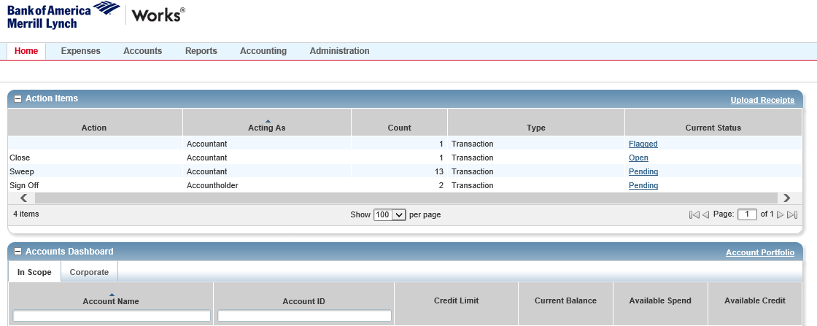

Click on “**Pending**”, Transactions – Accountholder window will prompt for all pending transactions that need to be reconciled.

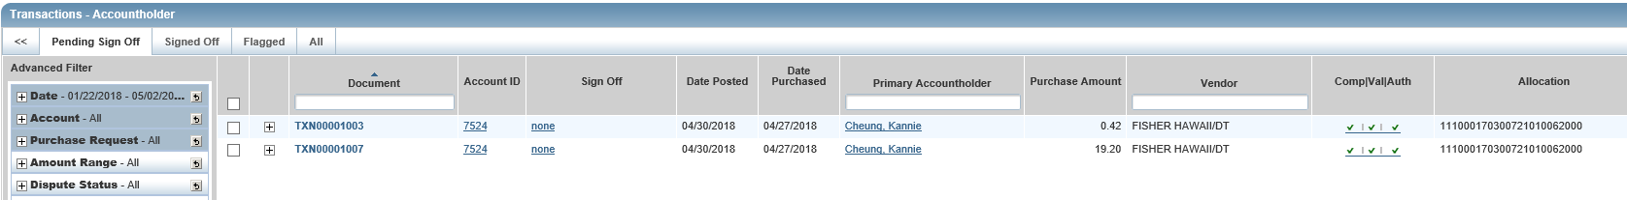

Click on a transaction document (e.g. **TXN########**), then select **View Full Details**.

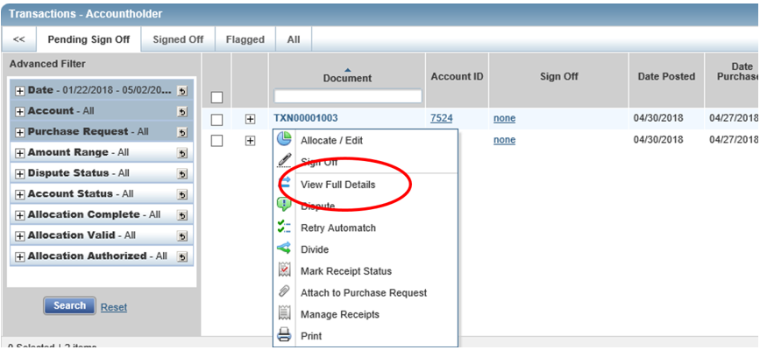

Click on “**Allocation & Detail**” tab to review and reconcile a transaction.

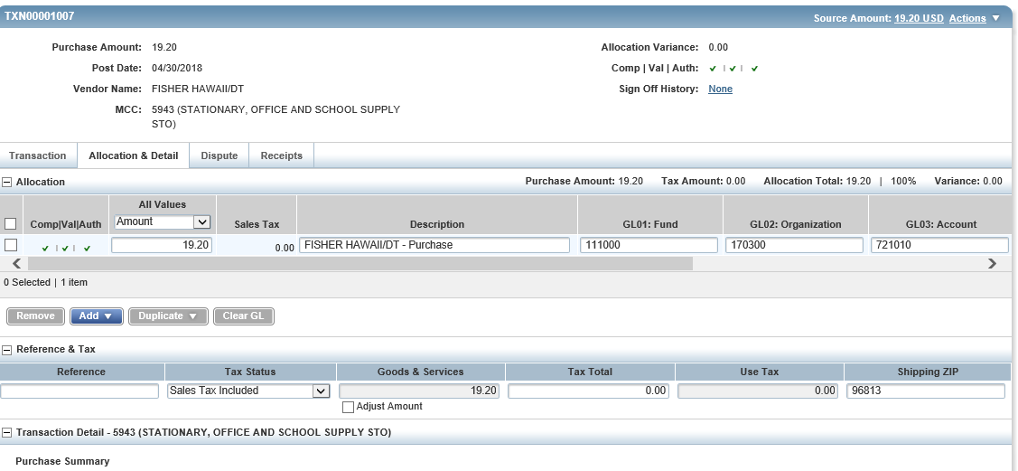

Change default language in **Description** field to indicate the purpose or justification of the purchase (**25 characters maximum limit. Of these, 19 characters will be uploaded in Banner as part of the transaction description in the system**). Your default coding should be automatically populated. However, review and update as needed, the Fund, Organization, Account and Program (FOAP). If applicable Activity and Location codes may need to be indicated.

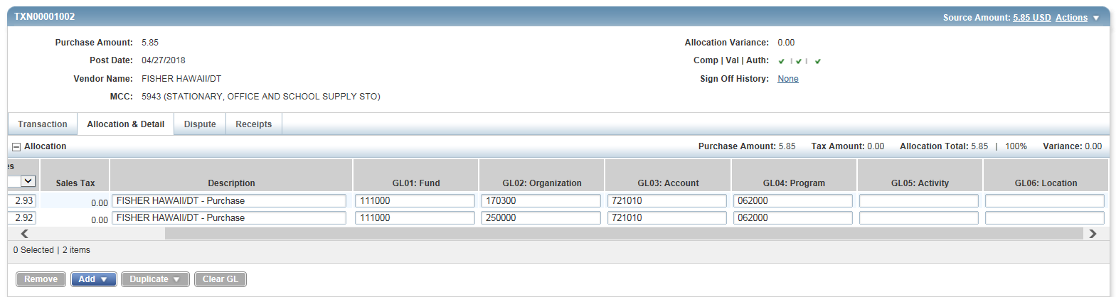

To allocate a charge to 2 or more FOAPAL, click on **Add** button and select the number of lines needed.

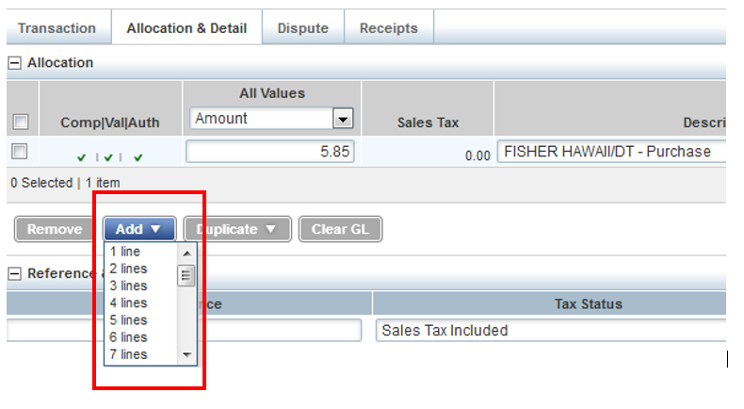

You may allocate by the amounts.

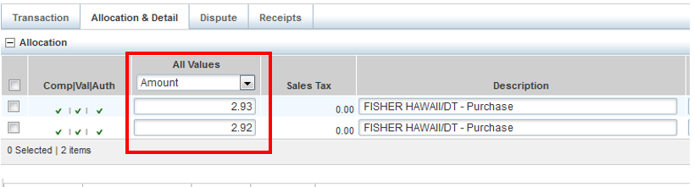

Or by percentage.

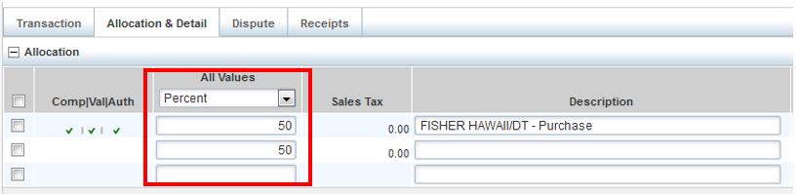

**Uploading and Attaching Receipts** –

Once you have updated the Description field and reviewed FOAPAL for propriety, click on “**Receipts**” tab. Then, click on “**Add**” button at the bottom and select “**New Receipt**”.

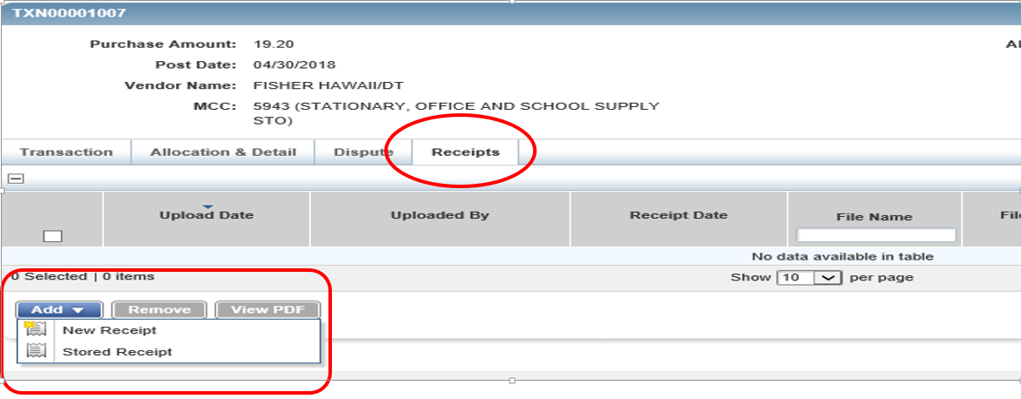

Once you clicked on **New Receipt**, the “Add Receipt” box will pop up. Click on the “**Browse**” button to browse into your desktop folder for scanned receipt for the transaction

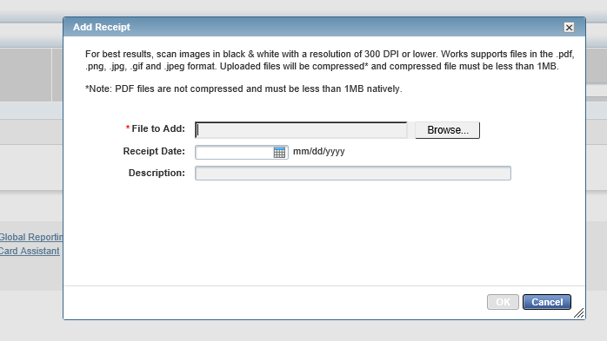

Once the scanned receipt is selected in the folder where you saved it (e.g. “Cheung $19.20 May18” was saved in Desktop, **click on the file** and click on “**Open**” button.

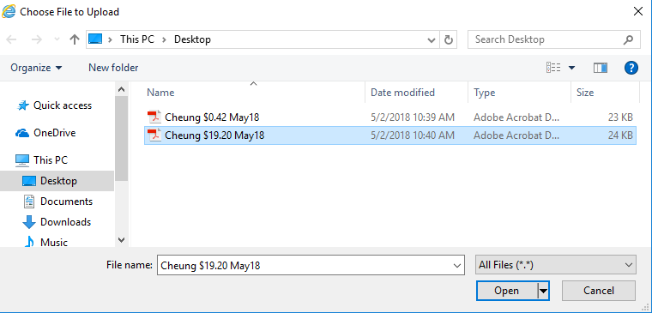

The file directory of the scanned receipt will appear in File to Add field.

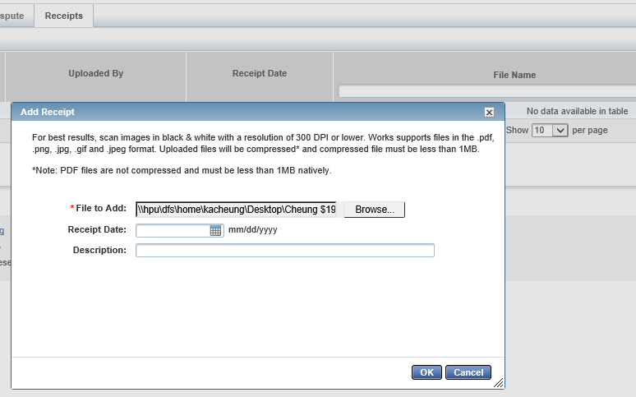

Click “**OK**”, scanned receipt file will appear in window

**Please have all Bank of America Merrill Lynch Purchasing Card receipts scanned and labeled with the following format - Last Name Amount MMMYY (e.g. Cheung $19.20 May18)**

You can review the attached receipt by either clicking on the file name or “**View PDF**” button. Please make sure **the receipt is legible**.

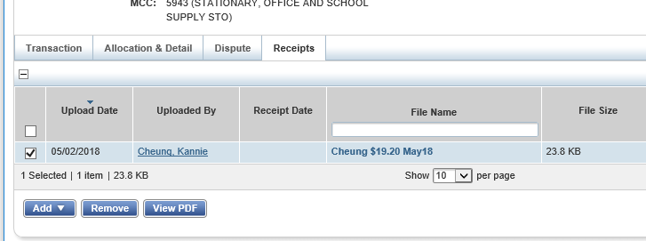

Once you have reviewed the receipt for accuracy, completeness and legibility, click on “**Actions**”, which is located on the right side of transaction amount.

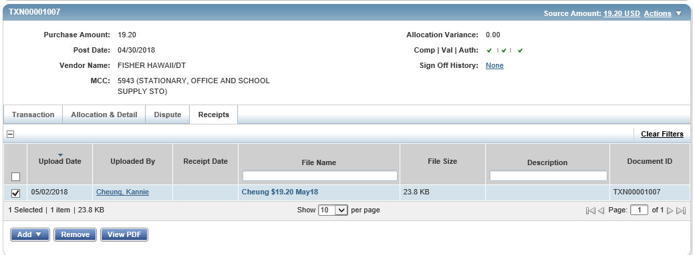

Then Select “**Save and Sign Off**” from Actions menu

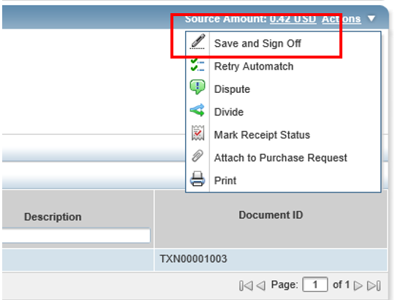

You may add Comments if additional information is needed for transaction such as who, what where and when for meal purchases.

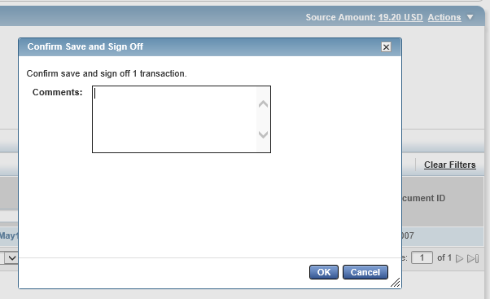

Click “**OK**” to sign off transaction.

**Printing Transactions**

If you wish to print the transactions in your queue, select the transactions and then click print tab.

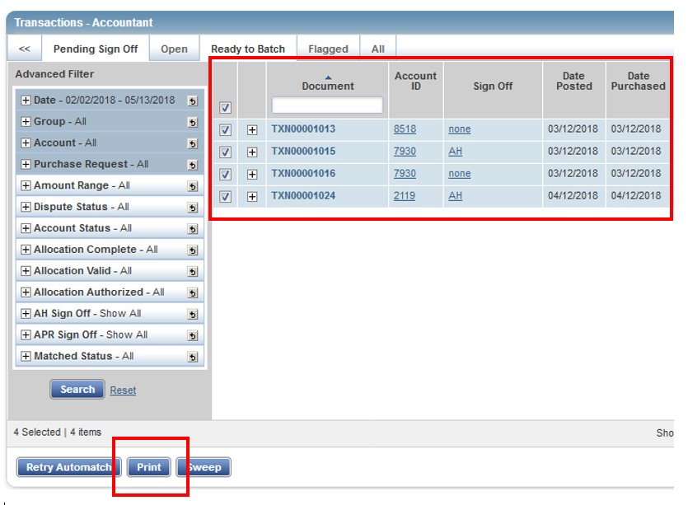

**Flagged Transactions**

If you have transactions that have been flagged by your approver due to incorrect coding, no receipt or other reasons, you will have to correct the transactions and then remove the flag.

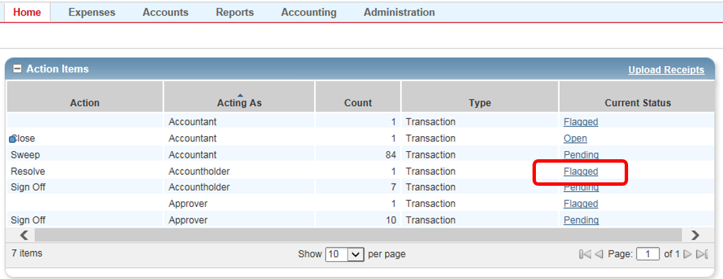

You can view comments made by your approver in the transactions comments column.

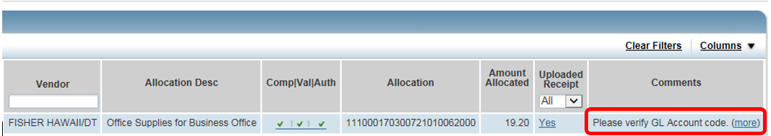

Once you have resolved the issue, you may remove the flag clicking the **Remove Flag** from the dropdown menu or **Remove Flag button** below.

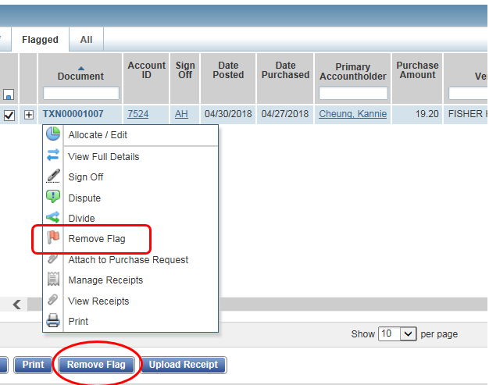

**Personal Expenses**

The personal charges on purchasing card should be avoided. If there is an inadvertent personal charge transaction, the cardholder must indicate in the description field, **Personal Charge** and the cardholder must reimburse the University the amount either by check or cash.

If there is an invoice that is part business and part personal, pay the merchant with the HPU business card for the business portion and pay with your personal funds the personal portion of the invoice.

**Cash Advance**

Taking a cash advance should be avoided. However, in rare occasions where in the purchasing card is not an acceptable form of payment and taking a cash advance is needed, you will have to reconcile the cash advance by filling out the Cash Advance form and return any remaining funds to the University, either through a check or cash. The form is available online at ***nexus.hpu.edu, under Divisions and Departments tab, Office of the CFO. Click on Forms – Logs – Vouchers.*** (<http://nexus.hpu.edu/dept/CFO/Forms%20%20Logs%20%20Vouchers/Forms/AllItems.aspx>).

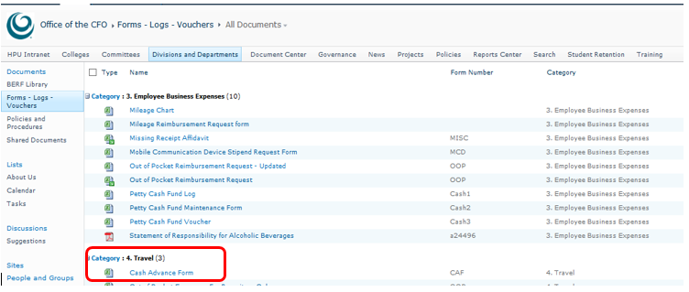

Upload into *Works* the scanned cash advance form along with the receipts to reconcile the cash advance transaction.

**Missing Receipt**

Receipts are required for each transaction and should be scanned into *Works* and reviewed by the Cardholder and submitted to their “Approver”, no later than the 31st of each month.

For purchases greater than $25 fill out a “Missing Receipt Affidavit” form, obtain the necessary approvals and scan into Works. For a purchase greater than $75, the IRS requires a receipt. At this point you will need to request a duplicate from the vendor.

**Out of Pocket and Mileage Reimbursements:**

Please note that in BAML does not have the capability to deposit funds via ACH to your personal bank account for out of pocket (OOP) expenses or mileage reimbursements. OOP expenses will be reimbursed via paper check. Fill out an OOP form and submit it along with your printed/hard copy receipts. The OOP form and Mileage Reimbursement form are available online at ***nexus.hpu.edu, under Divisions and Departments tab, Office of the CFO. Click on Forms – Logs – Vouchers.*** (<http://nexus.hpu.edu/dept/CFO/Forms%20%20Logs%20%20Vouchers/Forms/AllItems.aspx>).

The Mileage Reimbursement Request form is also available on this site.

