**To Approve BAML Purchasing Card Transaction(s)**

Log in to Bank of America Merrill Lynch (<https://payment2.works.com/works/>). Once signed in, charge transactions awaiting for your approval will display in **Action Items** box, labeled **Pending** as current status.

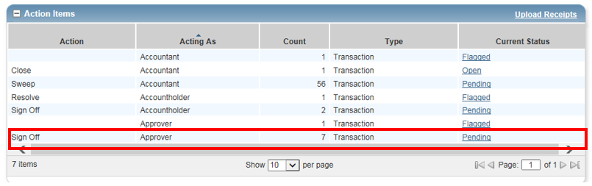

Click on “**Pending**”, **Transactions** – **Approver** window will display all pending transactions that need to be reviewed and approved.

Alternatively, you may click on “**Expenses**” tab, which is located on the top left corner of the screen, cursor to **Transactions** and click on **Approver.** (Expense 🡪 Transactions 🡪 Approver)

Transactions – Approver window will display

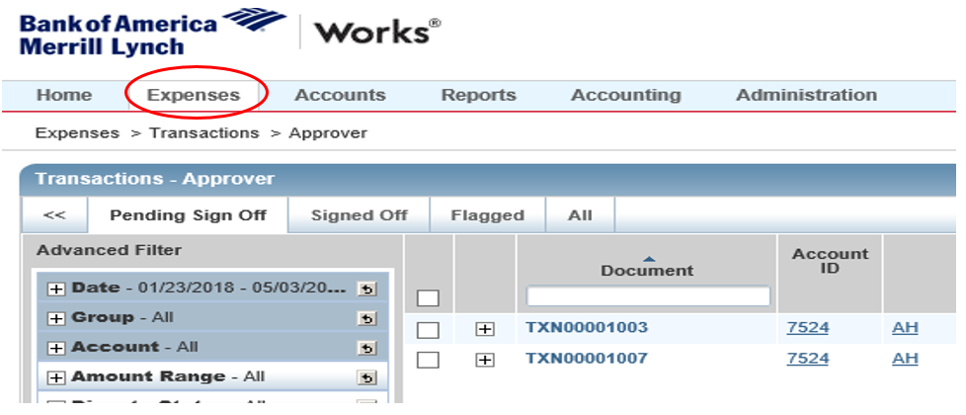

Transactions – Approver “Pending Sign Off” window provides you the overview of all transactions of Account holders under your supervision.

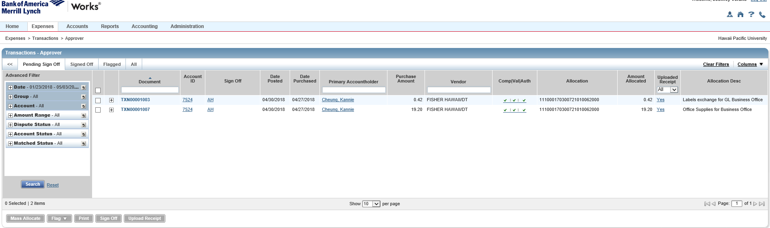

Click on **Document#** (e.g. **TXN########**) to select “**View Full Details**”

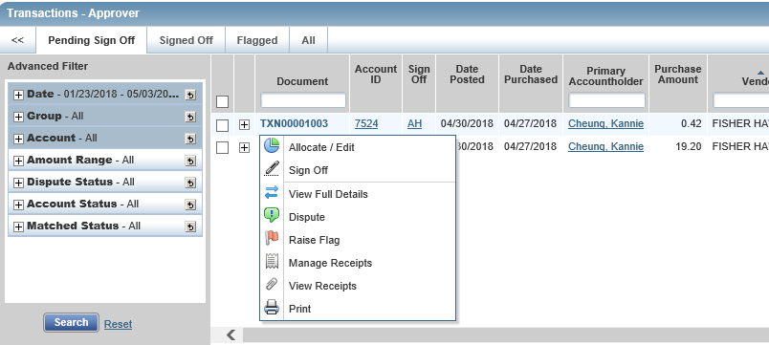

Click on “**Allocation & Detail**” tab

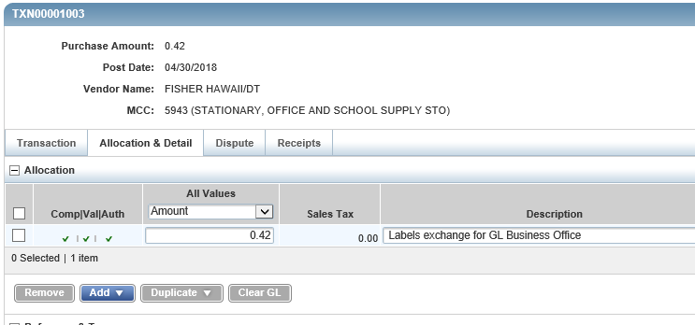

**In Allocation & Detail screen, review the purchase transaction as well as the Description and assigned FOAPAL**. Review the description and FOAPAL on additional lines if split allocation applies to the purchase.

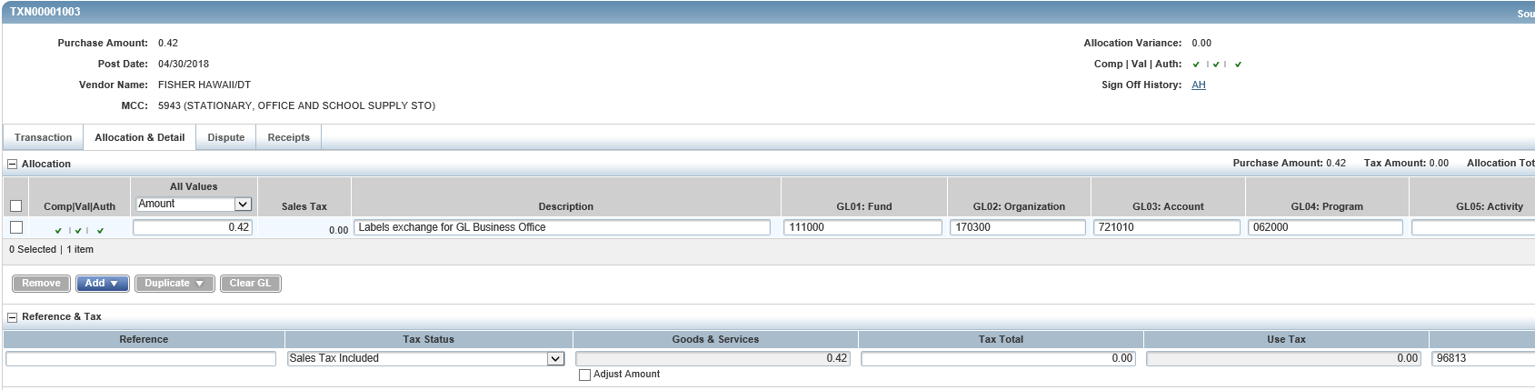

Then click on **Receipts** tab to review the receipt. While reviewing the receipt for valid business purpose, please confirm that the receipt contains all the itemized details, is legible and matches with purchase transaction.

We recommend labeling the receipt/invoice as follows: **Last Name Amount MMMYY** (e.g. Cheung $0.42 May18)

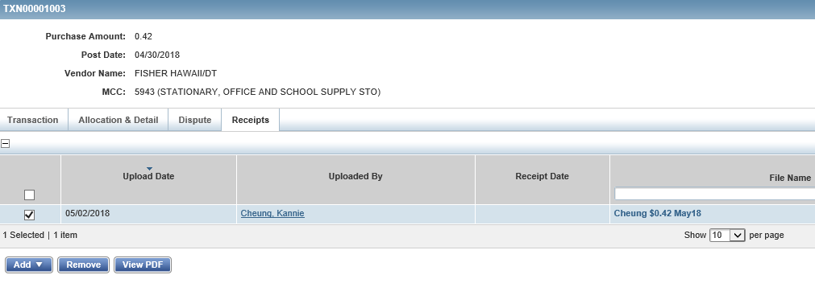

There are two ways to review receipt for transaction when you in full detail:

One way- Click on **View PDF**” button and click on **Open**.

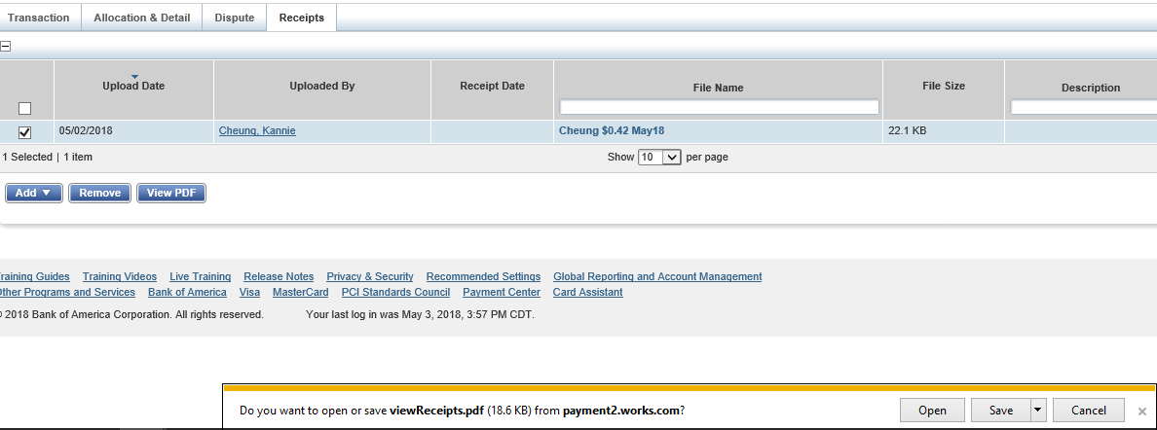

Another way – click on **File Name** (e.g. **Last name Amount MMMYY**) and click on “**View Receipt**”

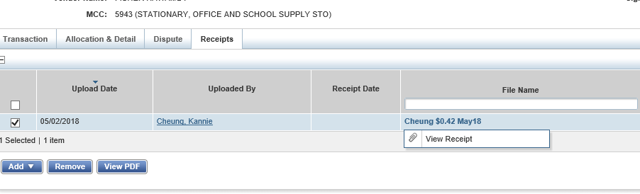

Once the receipt is reviewed along with the GL coding and description, click on **Actions**, which located on the top right of the transaction window. Then Click on **Save and Sign Off.** 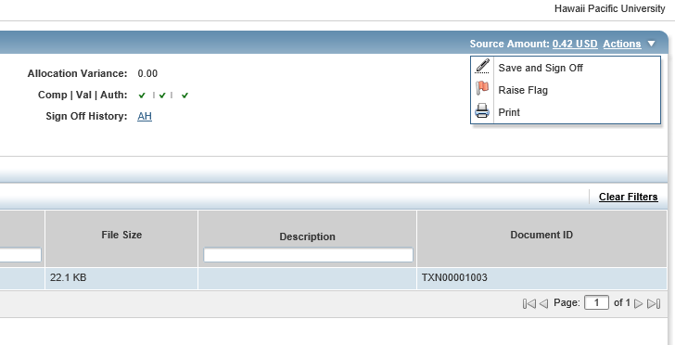

You may sign off or approve on all transactions at once by placing a **check mark** at the top left corner box if ***all information such as amount, Description, FOAPAL are correctly entered and receipts are uploaded for transactions*** on Transactions – Approver – Pending Sign Off window. Then click on **Sign Off.**

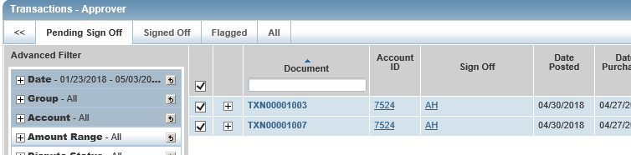



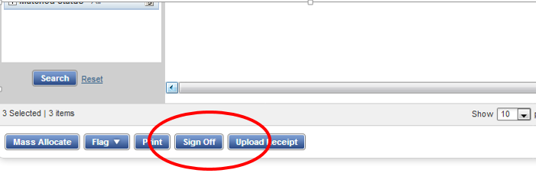

**Raising a Flag on a transaction**

If there is a correction that needs to be made by the cardholder, the approver may reject the transaction by clicking “Actions” on the top right corner and then “Raise Flag”, while in the View Full Details window.

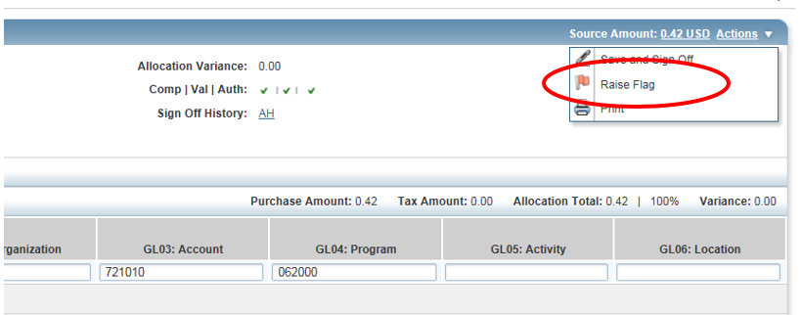

Or you may click on the **transaction document reference (e.g. TXN00001024)** and click on **Raise Flag** on the drop down menu.

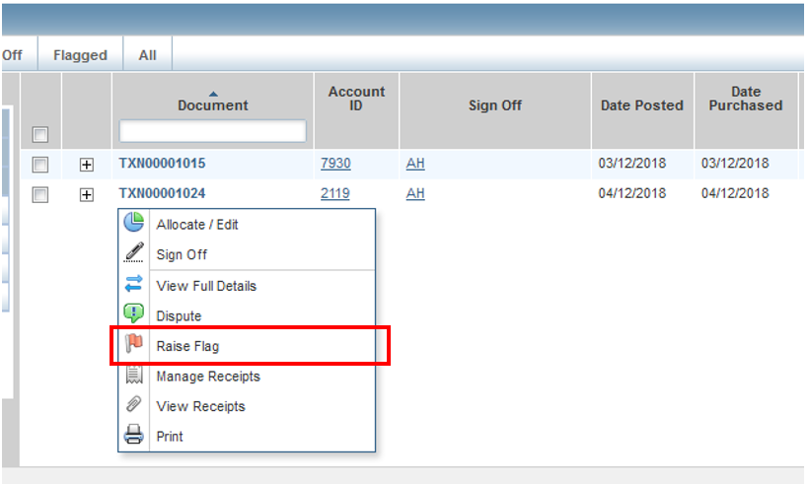

Indicate the reason for flagging the transaction in the Comments box, then click “OK”.

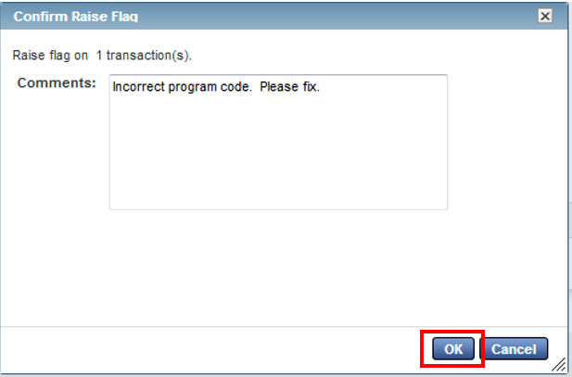

The cardholder will be able to view this transaction on the actions box. A notification will also be sent via email to the cardholder that a transaction has been flagged.

**Out of Pocket and Mileage Reimbursements:**

Please note that BAML does not have the capability to deposit funds via ACH to personal bank account for out of pocket (OOP) expenses or mileage reimbursements. These reimbursements will be routed directly as hard copy for your review and approve, prior to submitting to the Business Office, Accounts Payable.

Your subordinate will fill out an OOP form and submit it along with printed/hard copy receipts. The OOP form and Mileage Reimbursement form are available online at ***nexus.hpu.edu, under Divisions and Departments tab, Office of the CFO. Click on Forms – Logs – Vouchers.*** (<http://nexus.hpu.edu/dept/CFO/Forms%20%20Logs%20%20Vouchers/Forms/AllItems.aspx>).

The Mileage Reimbursement Request form is also available on this site.

