

Campus Resource Guide for Faculty and Staff

Prepared by the University Student Success Committee

August 27, 2018

**OFFICE DIRECTORY**

Academic Advising 544-1198

Admissions 544-0238

Athletics and Campus Recreation 356-5214

Barnes and Noble Bookstore 544-0290

Business Office 356-5272

Campus Activities Board

Career Development Center 544-0230

Center for Academic Success Accessibility Services 544-1197 Tutoring Services 544-9334 Testing Services 544-9334

College of Business 544-0283

College of Health and Society 236-5808

College of Liberal Arts 544-9340

College of Natural and Computational Sciences 236-5853

College of Professional Studies 544-1179

Counseling and Behavioral Health Services 687-7076

Dean of Students 687-7014

eSports Arena

Financial Aid 544-0253

Faculty Senate/Assembly

Faculty Senate & Assembly Administrator 544-0848 Faculty Senate Chair 544-1415

First-Year Experience 544-1116

General Education 544-1143

Help Desk 566-2411

Housing and Residence Life 544-0277

Human Resources 544-1188

International Students and Scholars 356-5299

Military/Veterans Center 356-5222

Parent and Family Relations 544-1116

Registrar’s Office 544-0239

Security 544-1400

Student Activities 544-0277

Student Dining 544-0277

Student Government Association

Study Abroad and International Exchange 544-9326

University Libraries

Atherton Library 236-3505

Learning Commons 544-1422

Meader Library 544-0210

**DEPARTMENTS AND PROGRAMS**

**Academic Advising**

1164 Bishop St. (UB Building), Ste. 123

(808) 544-1198 or [advising@hpu.edu](mailto:advising@hpu.edu) / [www.hpu.edu/advising](https://www.hpu.edu/academic-advising/index.html)

Office Hours: Monday – Friday, 8 a.m. – 5 p.m.

Academic Advising is committed to preparing students for success in the academic setting by assisting students in the development of skills to define and achieve their academic goals. Advisors provide assistance with registration, declaring or changing a major, minor, and/or concentration, creating degree plans, understanding degree and university policies/ procedures, and assisting with academic progress. Please contact Academic Advising for individual advisor availability.

**Admissions**

1164 Bishop Street, Suite 1100 and 1 Aloha Tower Drive, Welcome Center   
(808) 544-0238 or [admissions@hpu.edu](mailto:admissions@hpu.edu) / [www.hpu.edu/admissions/index.html](http://www.hpu.edu/admissions/index.html)

Office Hours: Monday – Friday, 8 a.m. – 5 p.m.

The admissions office provides assistance for students seeking entry into the university for both undergraduate and graduate students.

**Athletics and Campus Recreation**

1166 Fort St. (FS Building)

(808) 356-5214 or [sharks@hpu.edu](mailto:sharks@hpu.edu) / [www.hpusharks.com](http://www.hpusharks.com)

Office Hours: Monday – Friday, 8 a.m. – 5 p.m.

The Department of Athletics at Hawai‘i Pacific University (HPU) provides a comprehensive program of personalized learning and development to each of its student athletes.  We are a member of the NCAA (Division II) and the Pacific West Conference.  There are currently 14 intercollegiate teams at the university including, Acrobatics and Tumbling, Baseball, Softball, Men’s & Women’s Basketball, Men’s & Women’s Cross Country, Men’s & Women’s Golf, Men’s & Women’s Soccer, Men’s and Women’s Tennis, and Women’s Volleyball.

**Barnes and Noble Bookstore**

**Downtown Campus Bookstore**

3 Aloha Tower Drive, Ste. 1207

(808) 544-0290 or [SM8094@bcnollege.com](mailto:SM8094@bcnollege.com) / <http://hpu.bncollege.com/webapp/wcs/stores/servlet/BNCBHomePage?storeId=74739&catalogId=10001&langId=-1>

Hours: Monday - Friday, 8:30 a.m. – 6:00 p.m. Saturday, 10:00 a.m. – 2:00 p.m.

**Hawaii Loa Campus Bookstore**

45-045 Kamehameha Highway, Academic Center   
(808) 236-3532 or [SM8095@bncollege.com](mailto:SM8095@bncollege.com) Hours: Varies throughout the year, please call or check our website

The Hawai‘i Pacific University bookstore system is comprised of the downtown and Hawaii Loa campus bookstores. Each location offers the required textbooks to support the educational programs on its campus. Students should plan to purchase textbooks from the campus bookstore where their classes are being held. Textbooks for online courses and military campus programs are stocked at the downtown campus bookstore and can be purchased or rented there or online at [www.hpu.bncollege.com](http://www.hpu.bncollege.com).

**Business Office**

1164 Bishop Street, Suite 1200

(808) 356-5272 or [businessoffice@hpu.edu](mailto:businessoffice@hpu.edu) / [www.hpu.edu/business-office/index.html](http://www.hpu.edu/business-office/index.html)

Office Hours:  Monday – Friday, 8 a.m. – 5:00 p.m.

The Business Office provides students with assistance in understanding the charges to their student account, setting up payment plans online, accepting and receipting payments online or in person, placing and removing holds on student accounts for non-payment of balances, processing stipend payments, servicing Nursing and Perkins loans, and processing financial aid refunds once the Financial Aid Office has awarded aid to the students.

**Campus Activities Board**

1 Aloha Tower Drive, Suite 1407

[cab@my.hpu.edu](mailto:cab@my.hpu.edu) / [www.hpu.edu/cab](http://www.hpu.edu/cab) / [www.facebook.com/CABHPU](http://www.facebook.com/CABHPU)

The Campus Activities Board (CAB) is a student-run organization that strives to enhance the Hawaii Pacific University student experience through quality entertainment, creative programming, and community involvement. CAB provides leadership development opportunities for students who desire hands-on experiences in event planning, communication, team work, conflict management, and building relationships to name a few. CAB welcomes any/all students to get involved. For more info on upcoming events or getting involved in CAB, interested students should email CAB directly or check the HPU events calendar.

**Career Development Center**

1164 Bishop St. (UB Building), Ste. 122.

(808) 544-0230 or [csc@hpu.edu](mailto:csc@hpu.edu) / [www.hpu.edu/cdc](http://www.hpu.edu/cdc)

Office Hours: Monday – Friday, 8 a.m. – 5 p.m.

The Career Development Center supports students in their college-to-career transition. Students in need of resources to create resumes, improve interviewing skills, and best practices for the job/internship search need look no further than HPU’s Career Development Center. The professional career advising team also assists students in registering for internships and administering career/personality assessments. To search for employment, including on-campus jobs, students should access Handshake via the Career Development Center’s webpage.

**Center for Academic Success**

**Accessibility Services**

1060 Bishop St. (LB Building), Ste. 602

(808)544-1197 or [access@hpu.edu](mailto:access@hpu.edu)

[www.hpu.edu/StudentServices/disability-resources-office/index.html](http://www.hpu.edu/StudentServices/disability-resources-office/index.html)

Office Hours: Monday-Friday, 8 a.m. to 5 p.m.

Accessibility Services is responsible for determining reasonable accommodations and comprehensive support services for students with disabilities and will interact with other departments to help ensure that programs and support services comply with ADA regulations.

**Center for Academic Success (cont.)**

**Testing Services**

1060 Bishop St. (LB Building), Ste. 600

(808) 544-9334 or [assessment@hpu.edu](mailto:assessment@hpu.edu) / [www.hpu.edu/testing](http://www.hpu.edu/testing)

Office Hours: Monday – Friday, 8 a.m. – 5 p.m.

The Center for Academic Success offers testing services to HPU students and non-HPU students. We provide placement testing for incoming students in Digital Literacy, Math, and Writing.  We also offer CLEP and DSST exams for college credit.  We also support our students with disabilities by offering approved accommodations as needed.  Our motto indicates the broad reach of our services: “Helping good students become great students.”

**Tutoring Services**

1060 Bishop St. (LB Building), Ste. 600

(808) 544-9334 or [tutoring@hpu.edu](mailto:tutoring@hpu.edu) / [www.hpu.edu/tutoring](http://www.hpu.edu/tutoring)

Office Hours: Monday – Friday, 8 a.m. – 5 p.m.

The Center for Academic Success offers tutoring services to HPU students.  Our main location is downtown, but we also provide limited services at HLC and ATM.  On the tutoring side, we offer peer-to-peer tutoring in the core areas of language-learning, math, science, and writing, as well as a number of other subjects.  We also provide academic success skill-building workshops (one-on-one and in groups) in subjects such as notetaking, test-taking, how to be successful in online classes, and more.

**College of Business**

900 Fort Street Mall (PL Building), Ste. 600/ (808) 544-0283/ [busadmin@hpu.edu](mailto:busadmin@hpu.edu) / [www.hpu.edu/cob/index.html](http://www.hpu.edu/cob/index.html)

Office Hours: Monday – Friday, 8 a.m. – 5 p.m.

The College of Business encompasses two groups: Financial Economics and Information Systems (accounting, economics, finance, information systems, management information systems, management science, real estate); and Management and Marketing (hospitality and tourism management, human resource management, international business, management, marketing, organization development and change). We encourage students with class-related issues to contact the department chair. Students may also direct questions to the college.

**College of Health and Society**

45-045 Kamehameha Hwy Hawaii Loa Campus

808-236-5808/ [www.hpu.edu/chs/index.html](http://www.hpu.edu/chs/index.html)

Office Hours: 8 am – 5 pm Mon – Fri.

The **College of Health and Society** (CHS) offers three distinct programs: Nursing, Public Health and Social Work. Each program offers both undergraduate and graduate programs.

The **Nursing Department** has an online doctor of nursing practice (DNP) program, including a one week intensive, for master’s prepared advanced practice registered nurses (APRNs). Within the Master’s of Science in Nursing program, there are two specialty tracks: 1) family nurse practitioner (FNP), and 2) adult gerontology acute care nurse practitioner (AGACNP); both have post-master’s certificate programs as well. Associate degree nurses (ADNs) may qualify for admission to the RN-MSN program. The Bachelor of Science in Nursing program has tracks for entry into the profession (BSN) and accelerated options for military corpsman (HM), licensed practical nurses (LPNs) and associate degree nurses (ADNs). The Bachelor and Master’s Degree programs as well as the Post-Graduate APRN Certificate Nursing program are accredited by the Commission on Collegiate Nursing Education (CCNE).

**College of Health and Society (cont.)**

The **Public Health Department** offers a Bachelor of Science in Public Health (BSPH) and a Master of Public Health (MPH) and will be accredited by the Council on Public Health Education (CPHE) by fall 2020 with backdated accreditation for the 2018-19 graduates.

The **School of Social Work** offers a Bachelor of Social Work (BSW) and a Master of Social Work (MSW) and is accredited by the Council on Social Work Education (CSWE).

All students with class-related issues are encouraged to contact the Chief Nurse Administrator (Nursing) or the respective Chairs in Social Work and Public Health. Students may also direct questions to the College of Health and Society office.

**College of Liberal Arts**

1166 fort Street Mall (FS Building), Ste. 200. / (808) 544-9340 / [cla@hpu.edu](mailto:cla@hpu.edu) / [www.hpu.edu/cla](http://www.hpu.edu/cla)

Office Hours: Monday – Friday, 8 a.m. – 5 p.m.

The College of Liberal Arts encompasses five different academic departments: Arts, Humanities, and Languages (art, art history, humanities, modern languages, music, philosophy, religious studies, theater); Communication (communication, mass communication, multimedia); English and Applied Linguistics (applied linguistics, English, and writing); History and International Studies (anthropology, DMS, GLSD. history, international studies, political science); and Psychology. We encourage student with class-related issues to contact the department chair. Please note that some classes in CLA disciplines are offered by CPS on military bases. Students are encouraged to contact CPS if they have concerns with course offered through that college. If in doubt, please contact CLA.

**College of Natural and Computational Sciences**

45-045 Kamehameha Hwy., Suite 206, Kaneohe, HI 96744-5297

(808) 356-5279 or [uogbodo@hpu.edu](mailto:uogbodo@hpu.edu)

**Departments of Math and Computer Science**

1060 Bishop Street (LB 402), Honolulu, HI 96813-2882

[www.hpu.edu/cncs/index.html](https://www.hpu.edu/cncs/index.html)

**Masters of Marine Science Program Office**

41-202 Kalanianaole Hwy, Waimanalo, HI 96795

(808) 259-3112 or [meyre@hpu.edu](mailto:meyre@hpu.edu)

Office Hours: Monday-Friday, 8 a.m. – 5 p.m.

Home of the Departments of Natural Sciences, Math, and Computer Science, the CNCS has a presence at Hawaii Loa Campus (HLC), the Oceanic Institute, and Fort Street Mall (DT). For issues related to individual classes or faculty, students are encouraged to first contact their respective department chair—Natural Sciences Dept. Chair: Dr. Georgianna Martin,[gmartin@hpu.edu](mailto:gmartin@hpu.edu), 808-544-0819, HLC AC 206 C; Math Dept. Chair: Dr. Patrick Perry, [pperry@hpu.edu](mailto:pperry@hpu.edu), 808-687-7061, DT - UB 520; Computer Science Chair: Dr. Stewart Crawford, [scrawford@hpu.edu](mailto:scrawford@hpu.edu), 808-544-0899, DT - UB 520.

**College of Professional Studies**

1164 Bishop St (UB Building), Ste. 500

(808) 566-2459 / [cps@hpu.edu](mailto:cps@hpu.edu) / <https://www.hpu.edu/cps/index.html>

Office Hours: Monday – Friday, 8 a.m. – 5 p.m.

Home of the Military Campus Programs, College of Professional Studies comprised of the School of Education (Elementary and Secondary Education) and the Department of Public Service (Homeland Security, Criminal Justice, Heath Professions, Supervisory Leadership, Human Resource Development, and Public Administration).  We encourage students with class-related issues to contact their respective department chair or directly to the college.

**Counseling and Behavioral Health Services**

<https://www.hpu.edu/health-services/counseling.html>

Counseling services are made available to provide support and help HPU students work through difficult or challenging life situations and/or changes through various counseling opportunities, including:

* Individual counseling
* Couples counseling
* Group counseling
* Family counseling
* Referral services
* Crisis support services
* Outreach Services

Licensed psychologists provide services at the Downtown and Hawai‘i Loa campuses. To schedule an appointment, please call (808) 687-7076. Counseling services are free and confidential to all registered HPU students.

**Dean of Students**

1164 Bishop St, Ste. 200

808-687-7014, [www.hpu.edu/studenthandbook](http://www.hpu.edu/studenthandbook)

Office Hours: Monday – Friday, 8 a.m. – 5 p.m.

FAQs: Student complaints, support services, events and educational awareness programs, behavioral concerns, Code of Student Conduct, sexual discrimination & sexual misconduct (Title IX), reporting procedures, alcohol and drug policy, off-campus meal program, health services and insurance, questions pertaining to appeal process, etc.

The Dean of Students staff is dedicated to supporting student success and an outstanding student experience at HPU. We deliver comprehensive services to foster a welcoming, caring, safe, and supportive learning environment where students have the opportunity to achieve their academic, personal and professional goals.

Primary functions include:

• Collaborate with students, faculty and staff to produce an engaging campus community.

• Connecting students with university resources, programs and services that may help them achieve their educational, personal and professional aspirations.

• Foster the holistic development of students (intellectual, moral, ethical, social, cultural, emotional, and physical).

• Assist students in understanding their student rights and responsibilities.

• Offer educational and prevention programs on various topics including alcohol, drugs, and sex discrimination

**eSports Arena**

1 Aloha Tower Dr, St.

808-544-087, [esports@hpu.edu](mailto:esports@hpu.edu)

Hours of Operation: Sunday – Thursday 11am -11pm | Friday - Saturday 12pm- 12am

The HPU eSports Arena is open to students and the public. Currently there are 24 high powered gaming computers, two virtual reality sets and four consoles stations with both Xbox and PS4 systems. Hawai‘i Pacific University is the first collegiate eSports Arena in the state of Hawaii. HPU is also the first college to offer competitive scholarships for eSport athletes in the state of Hawaii. Our scholarships are awarded to League of Legends student athletes who will be competing in the University League of Legends competitive circuit.

**Faculty Senate/Assembly Office**

1164 Bishop St., (UB 8th Floor)

Faculty Senate & Assembly Administrator: (808) 544-0848, jnakano@hpu.edu

Faculty Senate Chair: (808) 544-1415, smarek@hpu.edu

Office Hours: Monday-Friday, 8 a.m.-5 p.m.

The mission of the Faculty Senate/Assembly Office is to assist the faculty members of the Hawai'i Pacific University in all areas and to be a resource for the university regarding the faculty.

**Financial Aid**

1164 Bishop St, (UB Building, Ste. 201

(808) 544-0253 or [financialaid@hpu.edu](mailto:financialaid@hpu.edu) / [www.hpu.edu/financial-aid/index.html](http://www.hpu.edu/financial-aid/index.html)

Office Hours: Monday – Friday, 8 a.m. – 5 p.m.

The Financial Aid Office administers all federal, state, institutional, private, and external financial aid for current and prospective students. Financial aid includes scholarships, grants, Federal Work Study, and loans. Administering financial aid includes entrance and exit counseling of loans, monitoring Satisfactory Academic Progress for federal aid, default management, and many other related areas.

**First Year Experience**

1 Aloha Tower Drive, Suite 1400

808-544-1116 | [readysetgo@hpu.edu](mailto:readysetgo@hpu.edu) / <https://www.hpu.edu/fye> / [www.facebook.com/hpufye](http://www.facebook.com/hpufye)

The Office of First Year Experience (FYE) develops and implements comprehensive programs and services that promote, support and enhance the academic and co-curricular experiences of first year students at HPU. In partnership with various departments within both Academic and Student Affairs, FYE works collaboratively to provide academic and student support services, foster learning communities, develop students' leadership skills, acclimate first year students to university life, and connect new students with returning students, faculty, and staff. Through FYE, students can engage with their Peer Mentor and Hanai volunteer, participate in a variety of engagement activities (HoloHolo and Live Hawaii), as well as take their professor to lunch through the Be My Guest program. Lastly, FYE also serves as a hub for family engagement. Please also see the Parents and Family Relations information. FYE is located within the Student Life office at Aloha Tower.

**General Education Program**

1164 Bishop St., (UB building), Suite 800/

(808) [544-1143 / vabordonado@hpu.edu](mailto:544-1143%20/%20vabordonado@hpu.edu)

Office Hours: by appointment

The General Education provides students with a liberal arts foundation, set in the rich cultural context of Hawai‘i. Diverse courses outside the major inspire lifelong learning by introducing students to ideas, perspectives, and experiences relevant to their lives. In addition, the General Education Program cultivates the skills, knowledge, and values expected of all educated persons through the achievement of specific student learning outcomes. The unique features of the general education are the Hawaiian context and Hawai‘i’s place as the crossroads of the Pacific. This curriculum is delivered to an internationally diverse, engaged student body and emphasizes multidisciplinary approaches, applied learning, and experiential learning, rooted in a tropical island community.

**Help Desk**

If students encounter technical difficulties, contact the ITS Help Desk at <http://hpu.edu/help>, [help@hpu.edu](mailto:help@hpu.edu) or call (808) 566-2411.

**Housing and Residence Life**

1 Aloha Tower Dr., Suite 1400

(808) 544-0277 or [housing@hpu.edu](mailto:housing@hpu.edu) / [www.hpu.edu/residence-life/index.html](http://www.hpu.edu/residence-life/index.html)

Office Hours: Monday – Friday, 8 a.m. – 5 p.m.

Housing and Residence Life assists residential students experiencing academic and non-academic challenges at HPU while creating referrals to other offices as necessary, provides educational programming to achieve a sense of community, and administers room assignments/changes, roommate mediations, and all housing related billing**.**

**Human Resources**

1164 Bishop St. (UB Building), Ste. 800.

(808) 544-1188 or [HR@hpu.edu](mailto:HR@hpu.edu) / [www.hpu.jobs](http://www.hpu.jobs)

Office Hours: Monday – Friday, 8 a.m. – 5 p.m.

Human Resources provides faculty, staff and student employment-related services, such as benefits, leave management, recruitment and employee relations.

**International Students and Scholars**

1164 Bishop Street (UB Building), Suite 200

(808) 356-5299 or [iss@hpu.edu](mailto:iss@hpu.edu) / [www.hpu.edu/oiss](http://www.hpu.edu/oiss)

Office Hours: Monday – Friday, 8 a.m. – 4:45 p.m.

The Office of International Students and Scholars (OISS) assists international students, scholars, and specialists with their immigration concerns. We advise on cultural adjustments, visas, passports, F-1/J-1 regulations, I-20/DS-2019, employment, practical training, or any other immigration issue. OISS serves as a resource for departments who are contemplating how to best cater to an international population.

**Military / Veterans’ Center**

1164 Bishop St. (UB Building), Ste. 912

(808-356-5222/ [va@hpu.edu](mailto:va@hpu.edu)

<https://www.hpu.edu/military-and-veterans/veterans-benefits/index.html>

Office Hours:  Monday-Friday, 8am. – 5 p.m.

The Veteran’s Center specializes in assisting students using VA educational benefits achieve their educational and professional goals.  Veteran benefit information, career counseling, mental health and supportive counseling, are available through personnel outbased from the Veterans Benefits and Health Administration.

**Parent and Family Relations**

1 Aloha Tower Drive, Suite 1400

808-544-1116 | [parent@hpu.edu](mailto:parent@hpu.edu)

[www.hpu.edu/parent](http://www.hpu.edu/parent)

[www.facebook.com/hpuparent](http://www.facebook.com/hpuparent)

Parent and Family Relations, housed within the Office of First Year Experience (FYE), is designed to provide a place for the parents and family members of HPU students to find support, networking, answers to questions, resources, and engagement opportunities. Initiatives that come out of this office are the Family Calendar, the HPU Ohana Newsletter, Letters of Aloha, and the Care-Pak program. Parents and Family Relations is located within the Student Life office at Aloha Tower.

**Registrar’s Office**

1164 Bishop St. (UB Building), Suite 216

(808) 544-0239 or [registrar@hpu.edu](mailto:registrar@hpu.edu) / [www.hpu.edu/registrar](http://www.hpu.edu/registrar)

Office Hours: Monday – Friday, 8:00am-5:00pm (HST)

The Registrar’s Office provides HPU students, faculty, and staff with a comprehensive information and service center for academic records as well as registration policies and procedures. The office is also responsible for issuing HPU ID cards.

**Security**

**Aloha Tower Marketplace**

1 Aloha Tower Dr., Building 4, Ground Floor

(808) 544-1400 / Cellular (808) 294-4276

Hours: Security Officers on duty 24 hours a day, seven days a week

**Downtown Campus**

(808) 321-1892

Hours: Weekdays, 6:30 a.m. – 10:30 p.m. / Saturdays, 7 a.m. – 5p.m. / Sundays, Closed

**Hawaii Loa Campus**

45-045 Kamehameha Hwy, AC, Ground Floor and Dining Commons, First Floor

(808) 236-3515 or 33333 from HPU Landline / Emergency Cellular (808) 478-2788

Hours: Security Officers on duty 24 hours a day, seven days a week

**Oceanic Institute Security Office****(Located in Maintenance Building)**

(808) 259-3170 / Cellular (808) 220-2899

Hours: Security Officers on duty 24 hours a day, seven days a week

The role of the department is to provide a safe and healthy environment which enhances the campus learning experience and supports the mission of the university. All Hawaii Pacific University students are required to obtain, carry and keep updated a university-issued identification card, the HPU UniCard.

**Student Activities**

1 Aloha Tower Drive, Suite 1400

(808) 544-0277 or [studentlife@hpu.edu](mailto:studentlife@hpu.edu) /[www.hpu.edu/student-activities](http://www.hpu.edu/student-activities/index.html) /

[www.facebook.com/StudentActivitiesAtHPU/](http://www.facebook.com/StudentActivitiesAtHPU/)

Office Hours: Monday – Friday, 8 a.m. – 5 p.m.

Student Activities enriches the HPU experience through programming which fosters leadership development, cultural immersion and engagement on local and global issues; thereby promoting and strengthening student connections to the university and greater community. Here, students can learn about ways to get involved through clubs, leadership programs, SGA, CAB, and the multitude of student activities that are planned each semester. Student Activities shares the same office space as the Dean of Students, First Year Experience, and Housing and Residence Life offices.

**Student Dining**

**Pier 9 by Sam Choy (Aloha Tower Marketplace)**

1 Aloha Tower Drive, Ste. 1101, Honolulu, HI 96818

(808) 544-0277 or [housing@hpu.edu](mailto:housing@hpu.edu)

Waterfront Lofts residents are required to purchase one of the 3 mandatory meal plans, which include $100 in Sharks Bucks that may be used at approved locations. Meals not used within one week's time do not carry over into the following week or semester. For more details and hours, visit <https://www.hpu.edu/residence-life/wfl-dining.html>. The resident meal plans are also available to commuter students, as are Commuter Block plans ([www.hpu.edu/offcampusdining](http://www.hpu.edu/offcampusdining)). A la carte meals are $10 breakfast, $15 lunch, $18 dinner).

**Dining Commons at Hawaii Loa Campus**

45-045 Kamehameha Hwy., Residence Life Area (see HLC Map), Kaneohe, HI 96744-5297

(808) 544-0277 or [housing@hpu.edu](mailto:housing@hpu.edu)

All students living in the HLC residence halls are required to purchase a meal plan, either 10 meals per week or 14 meals per week and each meal plan includes $100 Dining Dollars each semester. Meals not used within one week’s time do not carry over into the following week or semester. None residents may purchase a meal at the door or at the lunch cart on the Academic Center lanai.

*Dining Commons Hours*

Monday - Friday Breakfast 7:30 a.m. - 8:30 a.m. Continental Breakfast 8:30 a.m. - 9 a.m. Lunch 11:45 a.m. - 1:15 p.m. Dinner 5:15 p.m. - 6:45 p.m.

Weekend/Holiday Brunch 10 a.m. - 11 a.m. Dinner 5:15 p.m. - 6:45 p.m.

Snack Bar Hours Sunday - Thursday 8:30 p.m. - 11 p.m.

**Sharks Bucks – HPU’s Off-Campus Meal Program**

Sharks Bucks is the student debit meal program at HPU that launched in fall 2016. This meal program is a cash-free alternative that will allow students to use their HPU UniCard like a debit card at participating merchants listed on the website throughout the valid terms. Stop by Student Life Office at ATM 1400 to sign up; or call Housing and Residence Life at 808-544-0277. Participating merchants include:

Visit [www.hpu.edu/sharksbucks](http://www.hpu.edu/sharksbucks) for details, sign-up information and a current list of merchants who accept Sharks Bucks.

**Student Government Association**

1 Aloha Tower Drive, Suite 1407

[sga@my.hpu.edu](mailto:sga@my.hpu.edu) / [www.hpu.edu/sga](http://www.hpu.edu/sga) / [www.facebook.com/SGAHPU](http://www.facebook.com/SGAHPU)

Senate Meetings: Fridays (in the fall and spring terms, excluding holidays), 3 p.m. – 4 p.m. in Multi-Purpose Room 1 at ATM.

The Student Government Association (SGA) of Hawai'i Pacific University is the student governing body that represents all students. The Student Body President is the chief representative and students’ advocate. The Student Senate serves as the legislative and oversight branch of SGA and seeks to promote the general welfare of the student body. SGA provides leadership development opportunities for students who desire hands-on experience in communication, shared governance, team work, conflict management, and advocating for student needs/issues to name a few. All students are encourage to attend weekly meetings of the Student Senate and to offer comments and concerns. For more information about vacant positions, interested students should email the Student Body President at: [sga@my.hpu.edu](mailto:sga@my.hpu.edu).

**Study Abroad & International Exchange Programs**

1164 Bishop St. (UB Building), Ste. 200

(808) 544-9326 or [studyabroad@hpu.edu](mailto:studyabroad@hpu.edu) / [www.hpu.edu/study-abroad/index.html](http://www.hpu.edu/study-abroad/index.html)

Office Hours: Monday – Friday, 8 a.m. – 5 p.m.

Please direct any HPU degree seeking students or prospective students to our office who is interested in traveling to another country for a semester, summer or year to study, intern and earn credit towards their degree requirements. Students who spend a term in another country may have questions about applying to programs abroad, how their credit will transfer back to HPU, how to use their financial aid or what other scholarships are available. We can help students with each step of the process as they plan to spend a short term away from HPU. Students can make an appointment on our website to discuss which of our 450+ programs in 70 countries is right for them.

**University Libraries**

The HPU Libraries and Learning Commons support student learning and faculty research with innovative services, resources, and facilities.   The Meader Library’s collections are primarily devoted to Business, Social Sciences and Computer Sciences, as well as English and other languages. The Atherton Library primarily supports the Diplomacy and Military Studies, Environmental Science, Marine Science, Nursing, and Pre-Health Studies degree programs.  Individual study carrels, study rooms, computer workstations, printers, photocopiers, media equipment, and wireless Internet are available at all locations. For research assistance while off-campus, reference librarians are available via a 24/7 online chat service. The "Ask Us" link is located in Blackboard and the Libraries' tab in Pipeline.

**Atherton Library (Hawai`i Loa Campus)**

45-045 Kamehameha Highway (3rd floor)

(808) 236-3505 or [atherton@hpu.edu](mailto:atherton@hpu.edu)

**Meader Library (LB Building)**

1060 Bishop St., Floors 2 – 5

(808) 544-0210 or [circulation@hpu.edu](mailto:circulation@hpu.edu)

**Learning Commons – Library Desk (Aloha Tower Marketplace)**

1 Aloha Tower Drive

(808) 544-1422

[www.hpu.edu/libraries/index.html](http://www.hpu.edu/libraries/index.html)

**Downtown Campus Map**

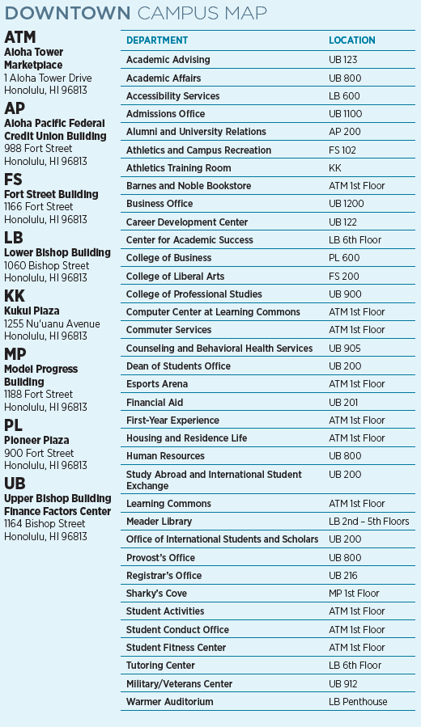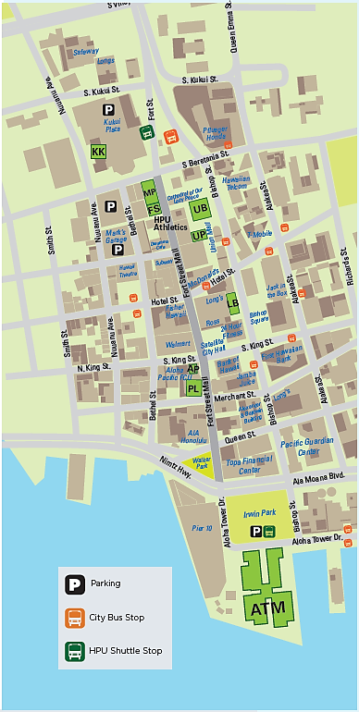

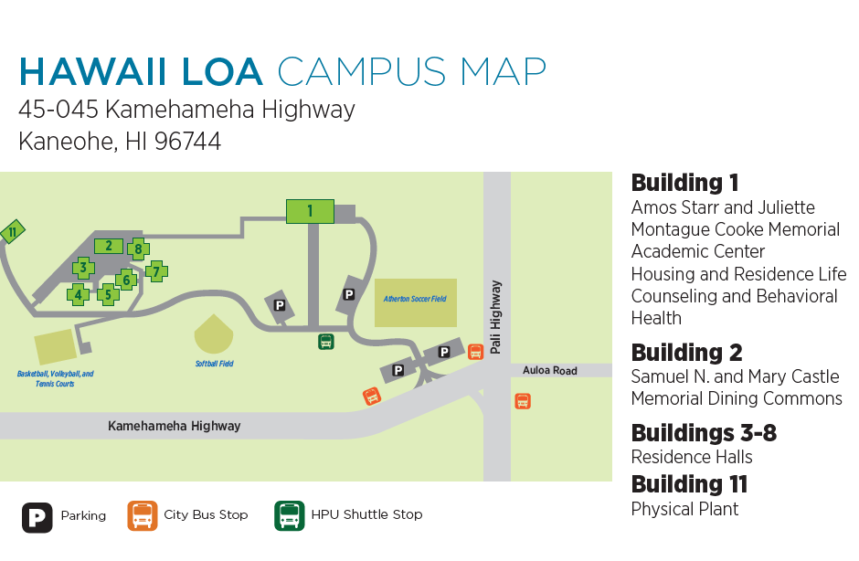**Hawaii Loa Campus Map**

**IMPORTANT NUMBERS**

**HPU Security**

ALOHA TOWER MARKETPLACE

HPU Security Center 544-1400

Cellular 294-4276

DOWNTOWN

Cellular 321-1892

HAWAII LOA CAMPUS

Front Gate 236-3515

Cellular 478-2788

LANDLINE

Downtown 11111

Hawaii Loa 33333

Director 22222

**HPU Housing and Residence Life**

Main Line 544-0277

HLC Area Coordinator 236-3541

HLC Resident Advisor Duty Cellular 375-0859

Waterfront Lofts Area Coordinator 544-1472

Waterfront Lofts Community

Advisor Duty Cellular 343-4885

**HPU Counseling & Behavioral**

**Health Services**

Main Line 687-7076

**MEDICAL EMERGENCY**

**Castle Medical Center**

Emergency 263-5164

Switchboard 263-5500

**Kaiser Permanente**

Honolulu 432-2000

Kailua 432-3400

Kane‘ohe 432-3800

Mapunapuna 432-5770

Moanalua 432-0000

**Kapio‘lani Medical Center for Women & Children**

Emergency 983-8633

Switchboard 983-6000

**Kuakini Medical Center**

Emergency 547-9540

Switchboard 536-2236

**The Queen’s Medical Center**

Emergency 691-4311

Switchboard 691-1000

**Straub Clinic & Hospital**

Main Line 522-4000

Kailua Family Health Center 263-9100

Kane‘ohe Family Health Center 233-6200

**OTHER IMPORTANT NUMBERS**

**AMBULANCE, FIRE, POLICE 911**

Alcoholics Anonymous 946-1438

Aloha United Way Info & Referral 211

Bilingual Access Line 526-9724

Crisis Access Line 832-3100

Department of Emergency

Management 723-8960

Domestic Abuse Hotline 841-0822

Domestic Violence Action Center 531-3771

Family Peace Center 832-0855

Hawaii Immigrant Justice Center 536-8826

HPU Food Pantry 544-9394

HPU Military/Veterans Center 356-5222

Kalihi-Palama Health Center

(Downtown) 792-5570

Legal Aid Society 536-4302

Narcotics Anonymous 734-4357

National Eating Disorder Assoc. 1-800-931-2237

Poison Center 1-800-222-1222

Planned Parenthood of Hawaii 589-1149

Sex Abuse Treatment Center

Hotline 524-7273

Suicide Prevention Lifeline 1-800-273-8255

Susannah Wesley Community

Center 847-1535

Veterans Center 973-8387